CENWP-OD-B 28 August 2023

MEMORANDUM FOR THE RECORD

SUBJECT: 23BON085 MFR Cascades Island LPS RB4 Pacific Lamprey Mortality

On the morning of 28 August, Project Biologists discovered one adult Pacific Lamprey mortality in the Cascades Island LPS Rest Box 4 (CI LPS RB4). The fish was scanned for PIT tags, inspected, and returned to the river.

- Species – Pacific Lamprey (Entosphenus tridentatus)
- Origin – Unknown
- Length – 57.2 cm
- Marks and tags – None
- Marks and Injuries found on carcass – None
- Cause and Time of Death – Unknown
- Future and Preventative Measures – None
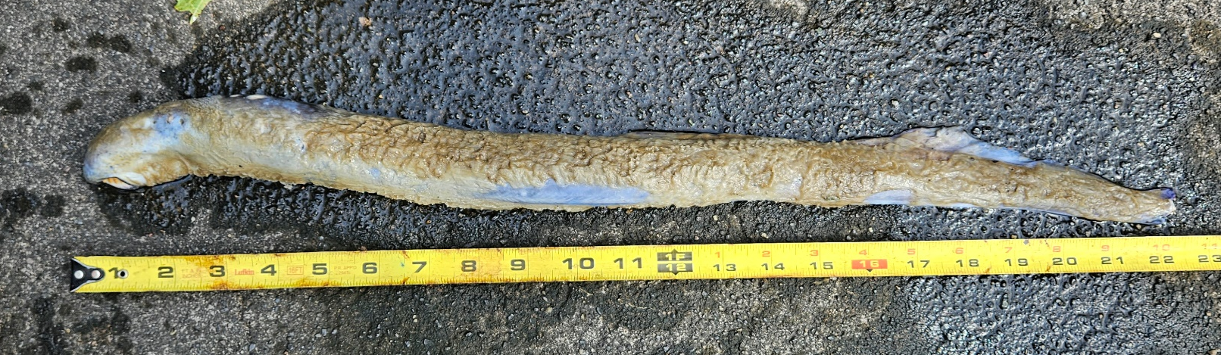

Sincerely,
BON Project Fisheries

